%% Calculation of Various entropies for given channel
clc;
clear all;
close all;
type = input('enter the type of channels','s');
switch type
case 'BSC'
m = input('enter the no of input messages=');
n = input('enter the no of output messages=');
for i = 1:m
for j = 1:n
pYbyX(i,j) = input('enter the conditional probabilities');
end
end
pYbyX
for i = 1:m
pX(i) = input('enter the input probabilities');
end
pX
for i = 1:m
for j = 1:n
pXY(i,j) = pYbyX(i,j) * pX(i);
end
end
pXY
for j = 1:n
pY(j) = sum(pXY(:,j));
end
pY
HX = sum(-pX .* log2(pX))
HY = sum(-pY .* log2(pY))
h = sum(-pXY .* log2(pXY));
HXY = sum(h)
HXbyY = HXY - HY
HYbyX = HXY - HX
IXY = HX + HY - HXY
C = log2(2) + pYbyX(1) * log2(pYbyX(1)) + pYbyX(2) * log2(pYbyX(2))
end

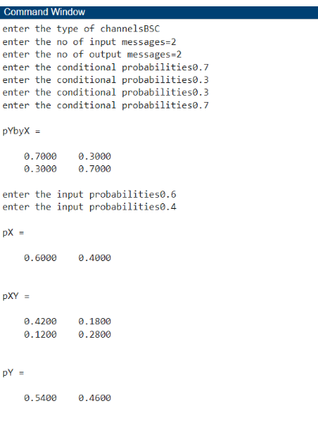

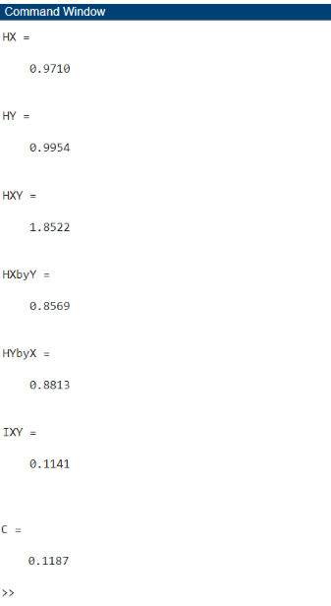
enter the type of channelsBSC
enter the no of input messages=2
enter the no of output messages=2
enter the conditional probabilities0.7
enter the conditional probabilities0.3
enter the conditional probabilities0.3
enter the conditional probabilities0.7
pYbyX =
0.7000 0.3000
0.3000 0.7000
enter the input probabilities0.6
enter the input probabilities0.4
pX =
0.6000 0.4000
pXY =
0.4200 0.1800
0.1200 0.2800
pY =
0.5400 0.4600
HX =
0.9710
HY =
0.9954
HXY =
1.8522
HXbyY =
0.8569
HYbyX =
0.8813
IXY =
0.1141
C =
0.1187
>>

